O que temos no C:
C:\Users\ailto\Atlas-Social-de-Hortolandia\dados\cadunico\01_bruto\2025_12
C:\Users\ailto\Atlas-Social-de-Hortolandia\dados\cadunico\02_limpo

C:\Users\ailto\Atlas-Social-de-Hortolandia\dados\cadunico\03_curado

C:\Users\ailto\Atlas-Social-de-Hortolandia\dados\cadunico\04_exportacao
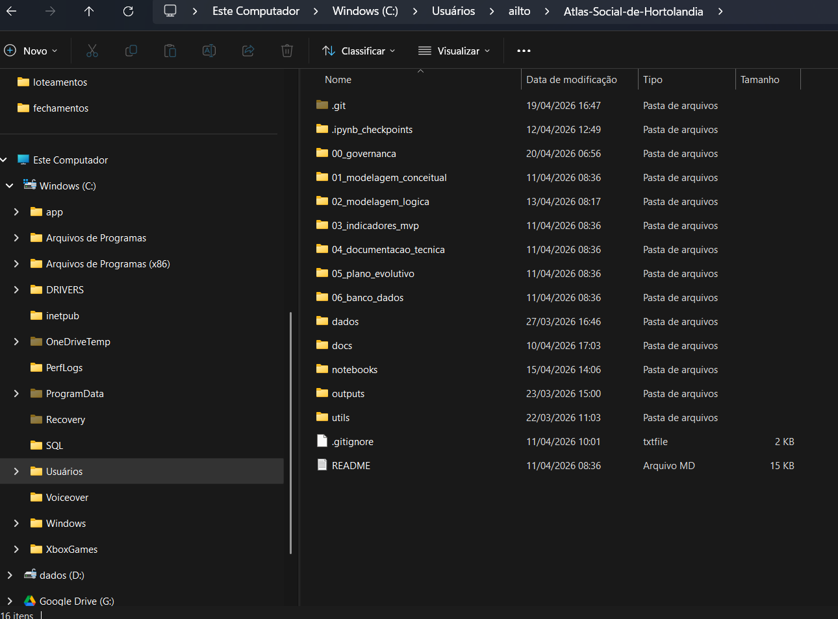
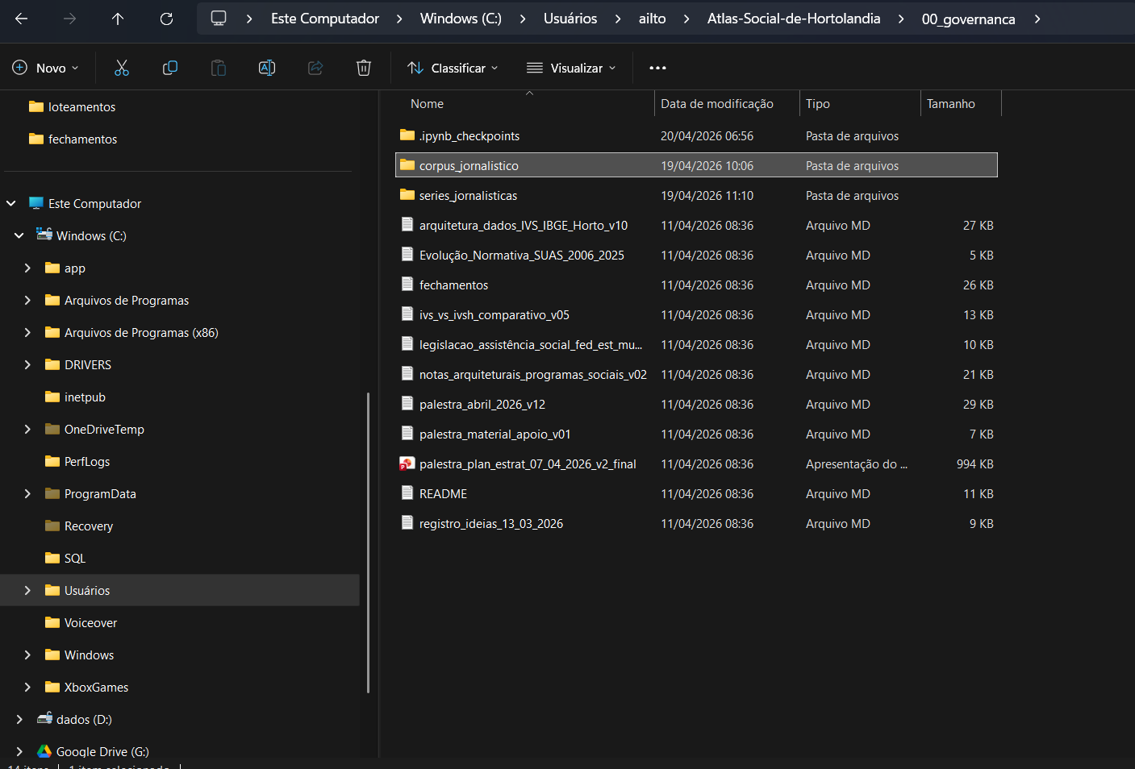

O que temos no Jupyter:
http://localhost:8888/tree/Atlas-Social-de-Hortolandia
http://localhost:8888/tree/Atlas-Social-de-Hortolandia/00_governanca
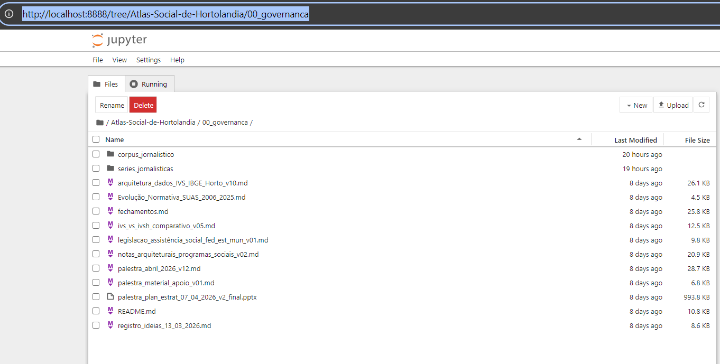
http://localhost:8888/tree/Atlas-Social-de-Hortolandia/00_governanca/corpus_jornalistico
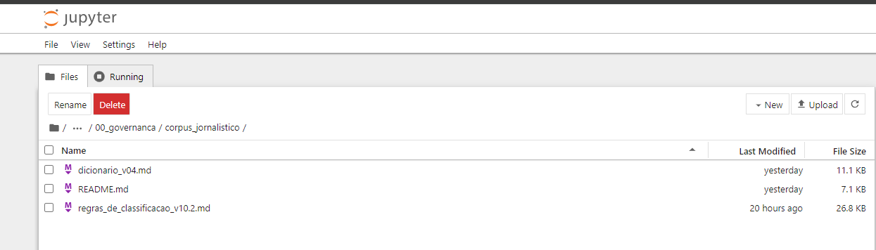

http://localhost:8888/tree/Atlas-Social-de-Hortolandia/00_governanca/series_jornalisticas
